 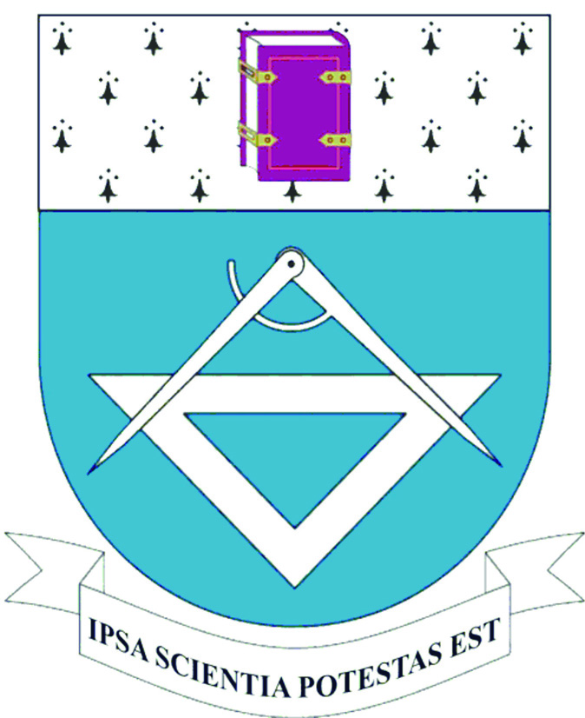    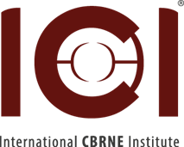 

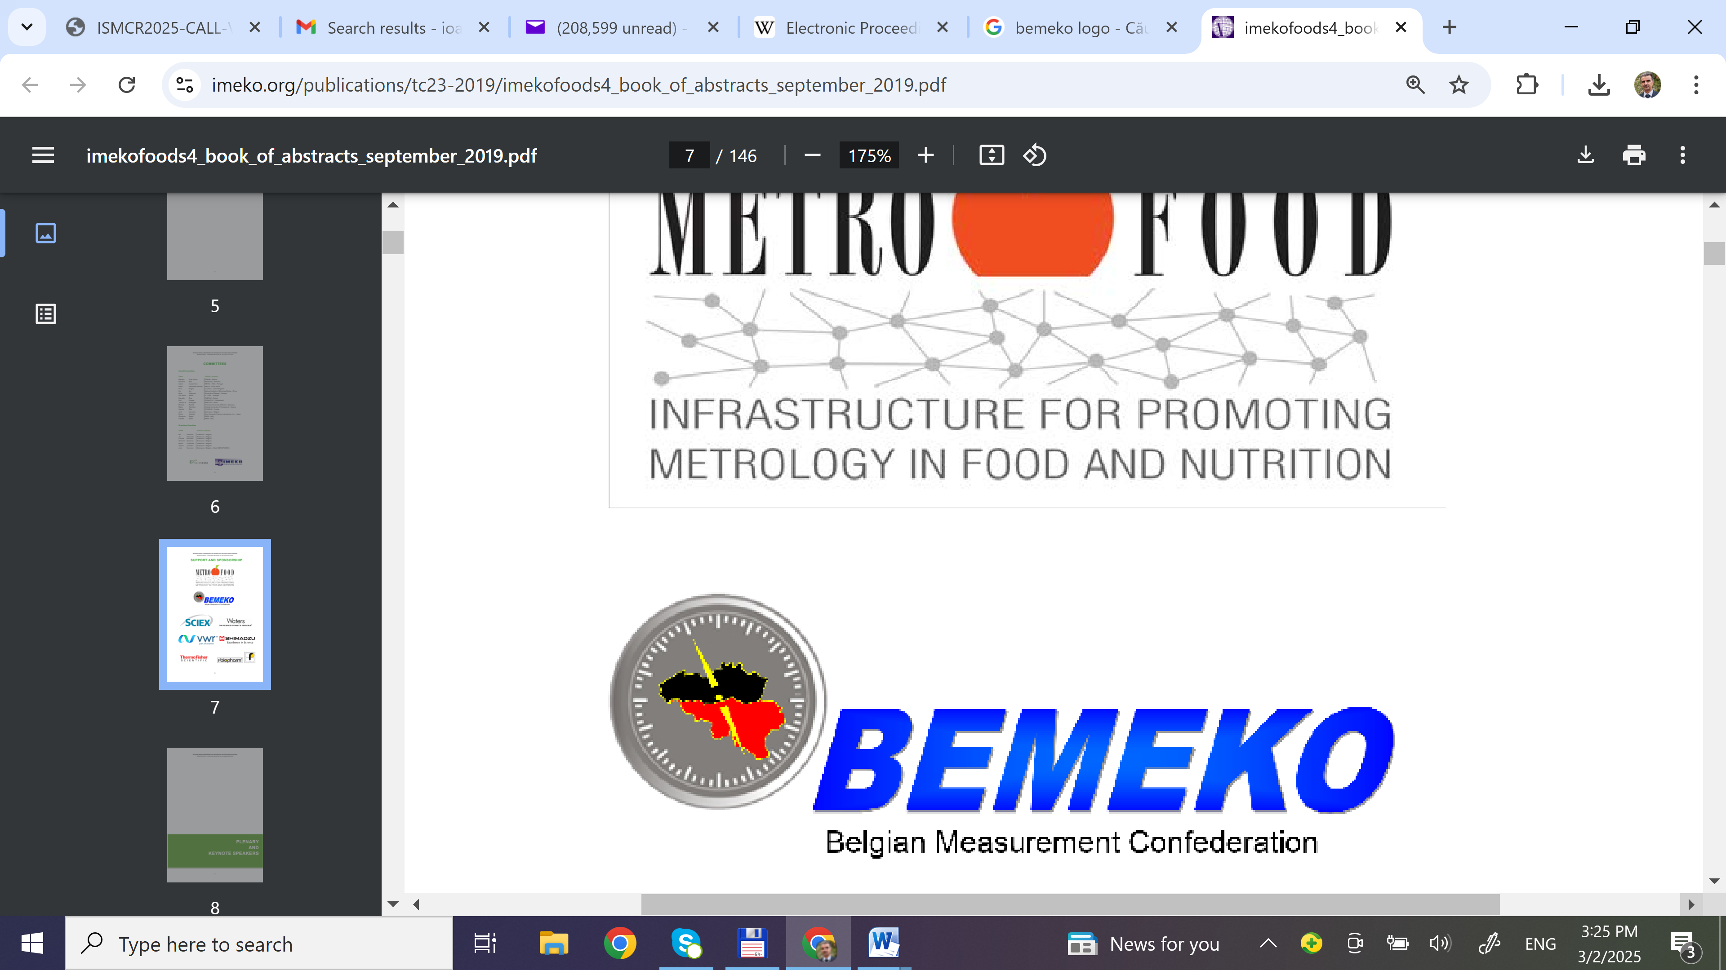

|  |  |  |  |
| --- | --- | --- | --- |
|  |  | logo |  |

ISMCR 2025

**26th International Symposium on Measurement and Control in Robotics**

***SAMBREVILLE, Belgium, October 07-08, 2025***

**Organized by**

The International CBRNE Institute (ICI)

**Under the Patronage of IMEKO – TC17**

International Measurement Confederation

Technical Committee 17 – Measurement in Robotics

**Symposium Chair**

Prof. EM Yvan Baudoin (Royal Military Academy, Manager ICI Explosives/Robotics Centre

**Symposium Co-Chairs**

Prof. Zafar Taqvi (USA)

Med. Dr. Ioan Galatas (ICI CBRN KC-Greece)

Prof. Frank Van Trimpont (ICI MED KC)

**Publication Chair and Review Co-Chair**

Prof. Ioan Doroftei (Romania)

**Financial Co-Chairs/Treasurers**

Y. Dubucq, Director ICI

Col. Marc Gilbert (Zone de Secours Sambreville)

**Logistic Chair**

[Prof. Simone Keller Füchter](https://www.imeko.org/index.php/tc17-homepage/tc17-members/1115-prof-simone-keller-fuechter) (Brazil)

**Executive Chair and Review Co-Chair**

Dr. Zafar Taqvi (USA)

**With the support of**

International CBRN Institute

CLAWAR Association

Technical Sciences Academy of Romania – ASTR

Academy of Romanian Scientists - AOSR

IEEE Galveston Bay Section

**International Scientific Committee**

Dr. Zafar Taqvi (USA)

Assoc. Prof. Bálint Kiss (Hungary)

[Prof. Simone Keller Füchter](https://www.imeko.org/index.php/tc17-homepage/tc17-members/1115-prof-simone-keller-fuechter) (Brazil)

Dr. Fumihiro KATO (Japan)

[Prof. Susumu Tachi](https://www.imeko.org/index.php/tc17-homepage/tc17-members/317-susumu-tachi) (Japan)

[Prof. Masahiko Inami](https://www.imeko.org/index.php/tc17-homepage/tc17-members/1078-masahiko-inami) (Japan)

[Prof. Jaromir Volf](https://www.imeko.org/index.php/tc17-homepage/tc17-members/777-jaromir-volf) (Czech Republic)

[Prof. C. Ferrero](https://www.imeko.org/index.php/tc17-homepage/tc17-members/767-carlo-ferrero) (Italy)

[Prof. Toshio Fukuda](https://www.imeko.org/index.php/tc17-homepage/tc17-members/768-toshio-fukuda) (Japan)

[Prof. K. T. V. Grattan](https://www.imeko.org/index.php/tc17-homepage/tc17-members/769-k-t-v-grattan) (UK)

[Dr. Zi Xue](https://www.imeko.org/index.php/tc17-homepage/tc17-members/907-xue-zi) (China)

[Prof. Andrej Babinec](https://www.imeko.org/index.php/tc17-homepage/tc17-members/1060-andrej-babinec) (Slovakia)

[Prof. Jean-Guy Fontaine](https://www.imeko.org/index.php/tc17-homepage/tc17-members/1063-jean-guy-fontaine) (Italy)

[Prof. Lino Marques](https://www.imeko.org/index.php/tc17-homepage/tc17-members/1066-lino-marques) (Portugal)

[Prof. Giovanni Muscato](https://www.imeko.org/index.php/tc17-homepage/tc17-members/1067-giovanni-muscato) (Italy)

[Prof. Jurek Z. Sasiadek](https://www.imeko.org/index.php/tc17-homepage/tc17-members/1114-prof-jurek-z-sasiadek) (Canada)

[Jagdish Shukla](https://www.imeko.org/index.php/tc17-homepage/tc17-members/1117-mr-jagdish-shukla) (India)

[Prof. A. Vimala Juliet](https://www.imeko.org/index.php/tc17-homepage/tc17-members/1116-prof-a-vimala-juliet) (India)

[Prof. Yanhe Zhu](https://www.imeko.org/index.php/tc17-homepage/tc17-members/1141-prof-yanhe-zhu) (China)

[Dr. Geert De Cubber](https://www.imeko.org/index.php/tc17-homepage/tc17-members/1142-dr-geert-de-cubber) (Belgium)

Dr. Gokcen Bas (Austria)

[Prof. Gregory Ya. Panovko](https://www.imeko.org/index.php/tc17-homepage/tc17-members/1214-prof-gregory-ya-panovko) (Russia)

[Prof. Sang-Youn Kim](https://www.imeko.org/index.php/tc17-homepage/tc17-members/1215-prof-sang-youn-kim) (Korea)

[Prof. Daniele Fontanelli](https://www.imeko.org/index.php/tc17-homepage/tc17-members/1260-daniele-fontanelli) (Italy)

Dr. [Trung T. Pham](https://www.imeko.org/index.php/tc17-homepage/tc17-members/1261-trung-t-pham) (USA)

Prof Osman Tokhi(UK)

**National Scientific Committee**

Prof EM Yvan Baudoin (RMA)

Prof Bram Vanderboght (VUB)

Prof Pierre Dehombreux (UMons)

Prof Dr Jean-Baptiste WATELET, (UGent)

Prof Frank Van Trimpont (ULB)

**Aim**

This symposium will focus on various aspects of research, applications and trends of robotics, advanced human-robot systems and applied technologies, e.g. in the fields of robotics, telerobotics, autonomous vehicles, simulator platforms, as well as virtual/augmented reality and 3D modelling and simulation.

Like its previous editions, ISMCR 2025 serves as a forum for the exchange of recent research results and novel ideas in robotic technologies and applications; this time with specific reference to smart mobility.

**Topics**

We are looking for original, high-quality contributions addressing (but not limited to) the following topics:

Robot Design Innovations; Sensors/Smart Sensors their Integration/Fusion; Advanced Controls and Actuators; Methods of Artificial Intelligence in Robotics; Humanoid, Climbing/Walking, Service, and Autonomous Robots; Anthropomorphic Robots/Mobile Robots; Tele-existence/Telepresence; Augmented Reality/Mixed Reality/Virtual Reality (VR); Communication with Realistic Sensations; Intelligent CAD and IMS; Visual/Auditory/Tactile/Force Displays; Tools and Techniques for Modeling VR Systems; Software Architectures for VR; VR Interaction and Navigation Techniques, Distributed VR Systems and Motion Tracking; VR Input and Output Devices; Innovative Applications of VR; Human Factors in VR; Evaluation of VR Techniques and Systems; Internet and VRML Application of VR in all areas; Interactive Art and Entertainment; Education and Entertainment Robots; Medical and Healthcare Robots; Micro and Nano Robots; Innovative Robotics Applications.

Counter-CBRNE Applications

**Submission, presentation and publication**

The official language of the symposium is English. Each paper (with a number of minimum 6 pages and maximum 10 pages; even number of pages) will be reviewed, and the papers selected by the Scientific Committee will be published by Springer in the series “Mechanisms and Machine Science”, indexed in Scopus, Ei-Compendex and Web of Science. All submitted papers must be strictly prepared following the publication guidelines. For detailed up-to-date information, please visit the ISMCR 2025 symposium website.

**Deadlines**

Full paper submission: June 30th, 2025

Paper acceptance notification: August 20th, 2025

Final paper submission: September 10th, 2025

**Registration**

Early Registration (before September 5th, 2025)

Authors and members of sponsoring institutions 150 €

Others 200 €

Students and Phders 50€/day

Exhibitors 300 €/day

Regular Registration

Authors and members of sponsoring institutions 200 €

Others 300 €

Students and Phders 50€/day

Exhibitors 300 €/day

Accompanying Persons 200 €

The fees include the lunches, gala dinner, ISMCR 2025 program and electronic version of the proceedings.

**orrespondence and Registration Chair Address:**

Prof. Yvan Baudoin

[yvan.baudoin@ici-belgium.be](mailto:yvan.baudoin@ici-belgium.be)

**Website**

<http://ismcr.org/2025-ismcr/>