SPONSORING and CO-SPONSORING SOCIETIES and INSTITUTIONS

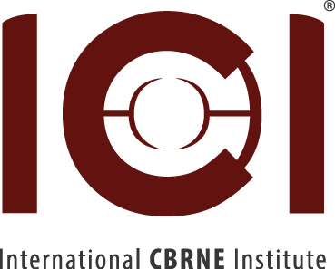
www.imeko.org-TC17

European Society for Defense
http://nct-europe.com/

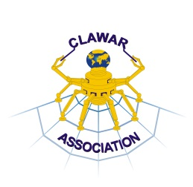 | 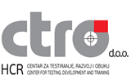
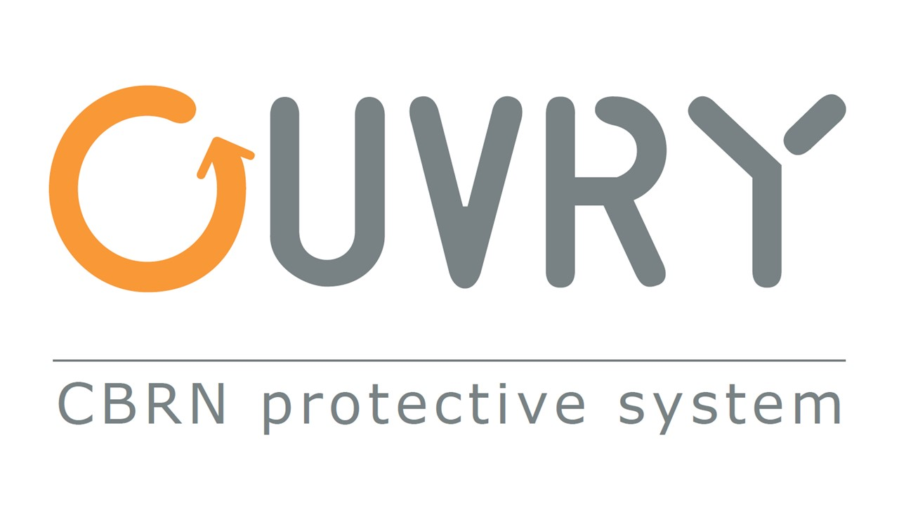



International Program Committee

Austria | Ms. Dr Gokcen Bas
Belgium | Dr Ir G.De Cubber
Brazil | Prof.Keller Füchter
Czech Rep | Prof J.Volf
France | Prof JG Fontaine  Col Rtd .Lefebvre
Canada | Prof. J. Z. Sasiadek
China | Prof. Yanhe Zhu
Croatia | Dr Ir N.Pavkovic
Germany | Dr K.Berns
Hungary | Prof B.Kiss
Italy | Prof G.Muscato
India | Mr. JagdishShukla
Japan | Prof M.Inami  Prof S.Tachi
Korea | Prof. Sang-Youn Kim
Poland | Prof.A.Maslowski
Portugal | Prof L.Marques
Romania | Prof I.Doroftei
Spain | Prof M.Armada
Slovakia | Dr Ir Babinec
Sweden | Dr T.Vikström
United Kingdom | Prof. K. T. V. Grattan
USA | Dr Ir Z.Taqvi

Time schedule

An abstract (approximately 200 words in English) should be received not later than May 6, 2022 Electronic submissions of the abstracts (PDF-files) should be mailed to:

Yvan.baudoin@ici-belgium.be

And

ztaqvi@gmail.com

- Abstract proposal deadline: May 6, 2022
- Final selection May 19,2022
- Receipt of full papers: After event, on selection for ACTA IMEKO

Local Organization Committee

Workshop inquiries to:
IMEKO TC17 VRISE2021
International CBRNE Institute
Rue de Sart-Dames Avelines, 8A
B6210 Les Bons Villers
Tel: +32 71820840
info@ici-belgium.be
Fax: Homepage
www.ici-belgium.be/events



www.bemeko.be – www.imeko.org
TC17-VRISE2021

International IMEKO TC17 special Session on Management of Risky Interventions and Environmental Surveillance

Physical Workshop at ICI

June 07-08 , 2022
www.ismcr.org

An International workshop on Measurement and Control of Robotics, focusing among others on virtual reality, risky interventions and environmental surveillance. This will follow the successful 7th IARP-RISE’2015 held at the Portuguese Naval Base (BNL), the 9th and 10th RISE’ 2019/2021 held at ICI, Belgium , the ISMCR’2018, 2019, 2020, 2021 held in Belgium, US, Hungary and Japan. It is aiming to gather high quality original contributions with the final goal of assessing the most recent developments in this utmost domain of science and technology. The Session scope covers a broad spectrum ranging from advanced conceptual and virtual design and methodology, sensors, actuators, instrumentation, and real-time control algorithms to innovative robotics, mobile (ground/aerial/undersea) robotics, personal and collective protection, multilevel rescue operations and management applications. It will contribute to provide a full picture of the state-of-the-art in the area of increasing risk or industrial s. The key words you will use are essential to organize the different sessions for this conference.
A physical Workshop and a Video-workshop will be held at ICI, at the same dates.

Scope and Topics
Measurement of CBRNE – related environmental risks
Environnemental surveillance (air quality, pollution, etc)
Search and Rescue by incidents/accidents/disasters)
Medical Management (teaching facilities, entertainment facilities, hospitality facilities, etc.)
Virtual Reality, Augmented Reality and Robotics Trends
Detection sensing systems

General Co-Chairmen
Prof em Y.Baudoin (ICI/RMA/ER KC)
Vice-Chair IMEKO/TC17
Dr Ir Zafar Taqvi (Chair IMEKO TC17)
Prof Laurent Francis (BEMEKO Chair)

Program Co-chairs
M.Y.Dubucq (Dir ICI)
Prof O.Tokhi (CLAWAR)
Dr F.Van trimpont ( EUROPEAN COLLEGE FOR DISASTER MEDICINE

with exhibitions of CBRNe tools.

