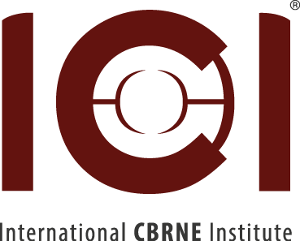
CBRN – E-RKC
www.ici-belgium.be
NEWSLETTER APRIL 2020

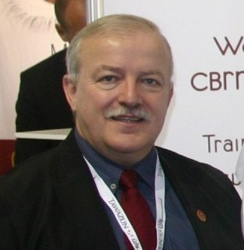 | 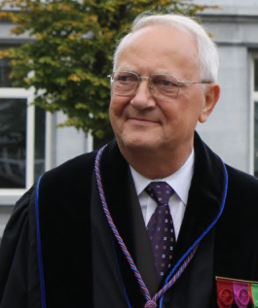 | 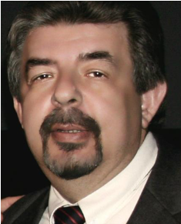
Yves DUBUCQ  Director of the ICI | Yvan BAUDOIN  Manager ICI/E-RKC | Ioannis GALATAS  Manager ICI/CBRN KC

1. Statement 2019

The year 2019 was as productive as 2018 in term of the visibility of our institution; in fact, no less than 30 countries were represented by delegates during this year either through their participation in our conferences or for having attended our courses. The focus this year has been set on the new courses given to emergency department staff of our hospitals on the one hand and on increasing our international visibility in the field of humanitarian demining and robotics on the other hand. Our main activities in 2019 were summarized in our Newsletter of December 2019:

5-8 February: Participation to the 22nd International Meeting of Mine action – National Program Directors and United Nations Advisers.
05 March, at ULB Erasme Hospital, conference for about 100 urgentists in their acquisition of the inter-university training in urgency management
07 March: CBRN Awareness Training of the NCT Team with Hotzone Solutions Group
01 April: 9th International ICI Workshop RISE’2019, focus on CBRNE Measurements and Management, with the support of BEMEKO (www.bemeko.be), NASK (Poland), HCR-CTRO (Croatia), Hotzone Solutions (The Netherlands), S€D (www.seurod.eu
8 April: The 16th international symposium on Mine Action has been organized by our Croatian Partners in DUBROVNIK (SLANO) from 8 to 11 April evaluator of the project).
25 -27 June: The ICI participates to the NCT-Europe 2019 in Vienna, involved in a workshop focusing on international cooperation and CBRNe training, under chairmanship of the Austrian Ministry of Defense and the Austrian Armed Forces
24 – 28 June: International course financed by UE in Yaoundé. The course was introduced by HH the representative of the Ministry of Interior of Cameroun and the UE representative M. Sébastien Bergeon.
17-19 September: the IMEKO TC17, organized the symposium IEEE- ISMCR’2019 in Houston (Clear lake university/NASA). Our ER-KC manager will take the chairmanship of IMEKO TC17 after ISMCR’2020 (October 2020).

29 April, 09 September, 14-16 October, ICI organized its level 2 and level 3 courses for the benefit of emergency department staff from hospitals

2. Past events and Pre-Planning 2020: due to the COVID 19 threat, dates of events may be adapted

- 11 to 14 February 2020 : the 23nd Meeting of Mine Action National Directors and United Nations Advisers (NDM-UN) took place at the Palais des Nations in Geneva, Switzerland. Four ICI partners participated: SITE (Sweden), CTRO (Croatia), BODAC (The Netherlands) and ICI (ERKC), with the support of the Ministry of Foreign Affairs. Read the report on https://mineaction.org/en/23rd-international-meeting-of-mine-action-national-directors-and-united-nations-advisers (session 7 in particular, devoted to the C-IED actions)
- 28 February: A conference has been organized, focusing on the security, with the indirect (coronavirus retains him in Greece) intervention of General I. Galatas (currently Member of the Center for Security Studies” (KEMEA), Athens, Greece (under the Ministry of Public Order & Civil Protection) and Manager of our CBRN KC), Dr J.Marsia, President of the AISBL S€D (Society for a European Defense – www.seurod.eu) and Dr C.Lefebvre (former Director of the CBRN Service of the French Ministry of Defense). And Dr Med F.Van Trimpont (General Secretary of European Council of Disaster Medicine): proceedings are available on www.ici-belgium.be/events
- 07-08 September 2020. The 10nd International (IMEKO TC17-ICI )Workshop on Measurement, Prevention, Protection and Management of CBRNE risks (RISE-MPPM-2020) will follow the successful 9th IARP-RISE’ 2019 (Risky Intervention-Environmental surveillance) held at ICI and it is aiming to gather high quality original contributions in the CBRNE field and associated CBRNE measurements, prevention, protection and management with the final goal of assessing the most recent developments in this utmost domain of science and technology. The workshop scope covers a broad spectrum ranging from advanced conceptual and virtual design and methodology, sensors, actuators, instrumentation, and real-time control algorithms to innovative robotics, mobile (ground/aerial/undersea) robotics, personal and collective protection, multilevel rescue operations and management applications. (visit: www.ici-belgium/event ). Note that, due to the COVID19, the RISE WS could be delayed to 15-17 October parallel to ISMCR’2020
- 21-24 September 2020: 17th International symposium on Humanitarian Mine Actions: this has been delayed and would be held in VODICE (Sibenik county). We invite the experts EOD/IED to attend this symposium organised by our associated CTRO company (www.ctro.hr ): contact Sanja Vakula (Sanja.vakula@ctro.hr)
- 15-17 October 2020: the ISMCR’2020 will take place in Budapest on. www.ismcr.org. The Call will be launched as soon as the Hungarian Government allows the organisation of symposia.
- 24-26 august 2020: the 23rd Symposium CLAWAR’2020 could take place in Moscow on: www.clawar.org: Confirmation as soon as the Russian Government allows it.
- CBRN Training (of First Responders): 18 May and 07 September (Level 2), 22-24 June 05-07 October (Level 3): please contact Yves.Dubucq@ici-belgium.be for confirmation or particular COVID 19 requests

3. HOTZONE SOLUTIONS
THE NEW COVID - 19 RAPID TEST KIT available: please read file:///C:/Users/User/AppData/Local/Microsoft/Windows/INetCache/Content.Outlook/2PUMX4L4/COVID-19%20-%20Test%20Kit%20HZS%20(Ver%201).pdf

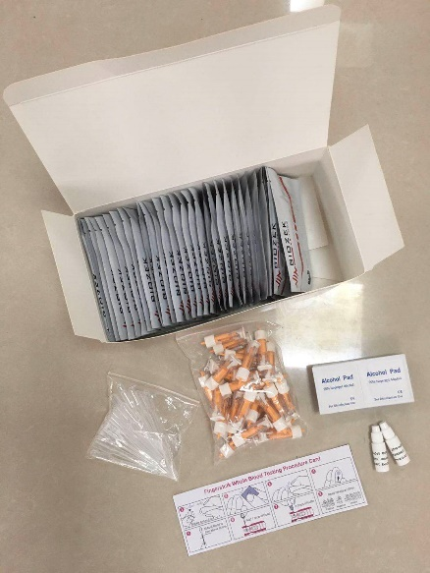

4 European Proposals (H2020, EDIDP, ERASMUS+).

- H2020 : DRS02 – 2019: RAPID (Rapid Accurate Pathogens Integrated Detection) : this proposal has been introduced in August 2019 and will not be funded: a redress request has been introduced. Results are expected by July 2020.

- ERASMUS+: CREATIVE (Gestural code foR Emergency Agencies: Training in Vocational Education) Due to the emergency situation that we are living in the whole europe, EU had postponed the deadline for the submission of the proposal CREATIVE. The version has now been loaded on the Erasmus+ Application portal. Partners are: UNIVERSITA DEGLI STUDI INTERNAZIONALI DI ROMA (Coordination), ICI (Belgium), EMERGENZA SORDI APS (Italy), UNIVERSIDADE DO PORTO, ITALIAN MINISTERO DELL'INTERNO, INSTITUT DE SEGURETAT PUBLICA DE CATALUNYA (Spain)

- H2020: New CALLS:

- SU-DRS01-2018-2019-2020: Human factors, and social, societal, and organisational aspects for disaster-resilient societies
- SU-DRS02-2018-2019-2020: Technologies for first responders
  - Sub-topic 3: [2020] Methods and guidelines for pre-hospital life support and triage
  - Sub-topic: [2018-2019-2020] Open (in particular: situational awareness and risk mitigation systems for first responders using UAV and robots)
- SU-DRS03-2018-2019-2020: Pre-normative research and demonstration for disaster-resilient societies
- Sub-topic 3: [2020] First aids vehicles deployment, training, maintenance, logistic and remote centralized coordination means"
- SU-DRS04-2019-2020: Chemical, biological, radiological and nuclear (CBRN) cluster
- ID H2020-SU-FCT 04-2020: Proposals should focus on the continuation of the work already done on some explosive precursors in previous FP7 and H2020 projects, including; tackling new precursors not yet studied. Proposals should tackle the chemicals and potentially their precursors in the usage other than explosives and explosive precursors covered under the first point, and propose means to decrease the vulnerability of the the public to their malevolent or terrorist use, along the full timeline of a potential criminal/terrorist plot (from early intelligence to the actual attack).
- SU-FCT04-2020 Chemicals: intelligence, detection, forensics
These proposal (all FORTHCOMING , not YET OPEN) could be discussed in parallel with the RISE Workshop (07-08 September 2020) and prepared from now on if partners (from previous proposals DISSUASIVE, EXODUS, RAPID) are showing their interest: contact Yvan.baudoin@ici-belgium.be)

- EDIDP
The following
A. CALLS EDIDP-CBRDEW2020,
B. EDIDP SME-2020,
C. EDIDP-CBRN-MCM-2020)
have been launched (on 15 April) by the EC. However, such proposals have to be sustained by the National Defense (MDN) of the partners included in the consortium AND their Industrial partners. I recommend You to take contact with your NAD (National Armament Directorate). Interested , Contact Yvan.baudoin@ici-belgium.be

We take advantage of this newsletter to once again assure our sponsors of our recognition. Their continuous support allows us to continue to develop for the benefit of all.

