Les Bons Villers, May 2018

Dear Colleague,

Enclosed You’ll find the registration sheet related to the 21st IMEKO International Symposium on Measurements in Robotics ISMCR’2018 and ELROB’2018

Please fill it and send it to me as soon as possible; your payment will validate your registration.

For any payment please consider the ICI account :

International CBRNE Institute
Rue de Sart Dames Avelines, 8A
6210 Les Bons Villers, Belgium
VAT : BE0539802426
IBAN: BE07 0688 9820 4566
BIC: GKCCBEBB.

The venue : MONS-Belgium (ELROB-ISMCR : rue de la Croix 112, B 7870 Lens-Mons)
The proposed accommodation ISMCR shuttle foreseen on 26/27 Sep (from the Congres Hotel MONS to the Symposium site)
Congres Hotel Van der Valk (https://www.hotelmons.eu/en)

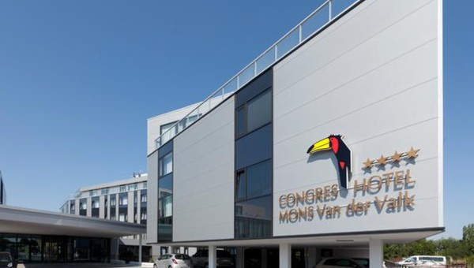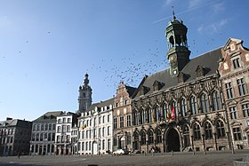

REGISTRATION
For EACH participant we need: Family Name – Nationality - Passport N° or ID Number

Surname – family NAME

Email

Address

Phone (fix or mobile)

Abstract title (if any)

Accompanying persons
Name
Name
Name

FEES (click on your category)

Category | Before July 01 | After August 01
Participants ELROB * □ | - | -
Author * □ | 250€ | 300€
Co-authors * □ | 300€ | 350€
Accompanying** □ | 150€ | 200€
Master/PhD Student*** □ | 50€/day | 50€/day
Exhibitor**** □ | 300€/day | 300€/day
Sponsor ***** □ | TBD | TBD
Visitors (not categorized above) | - | 30€/day (lunch included)

*The fees (for authors, co-authors, Master/PhD students) include lunches, get together diner, social events and proceedings (* 500€ Team-fees ELROB)
**The fees for accompanying persons (spouse/companion) include the lunches, get together dinner and social events
****The fees for exhibitors include a large space (take contact with yves.dubucq@ici-belgium.be for your requests and a possible oral presentation during the ISMCR sessions.
For the exhibition, we need before end of July your requests in term of Mat & Eqt to be on place upon arrival (tables, chairs, power, light…)
***** The sponsorship fees will be discussed directly with Mr DUBUCQ (+32 479 893742)

SOCIAL EVENTS

Get Together in the Congres Hotel MONS

Visit of MONS (www.visitmons.be)

Visit of Pairi Daiza (www.pairidaiza.eu)

If you need more information, contact yvan.baudoin@ici-belgium.be

Yves DUBUCQ
Managing Director
International CBRNE Institute (ICI)
Rue de Sart-Dames-Avelines, 8A
B6210 Les Bons Villers (Frasnes Lez Gosselies)
BELGIUM
+32 479 893742

