
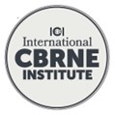
www.ici-belgium.be

NEWSLETTER December 2025

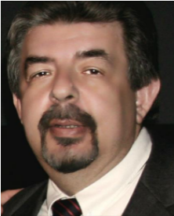
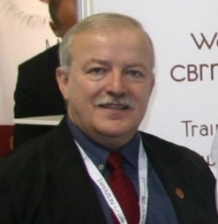
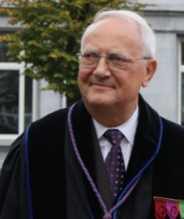


Yves DUBUCQ  Chairman of the ICI | Yvan BAUDOIN  Manager ICI/ER KC | Ioannis GALATAS  Manager ICI/CBRN KC | Frank VAN TRIMPONT  Manager ICI/MED KC

1. Statement 2025
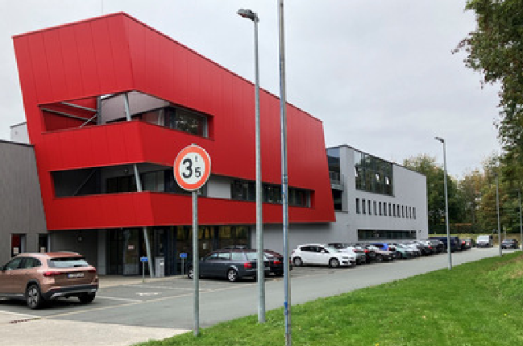
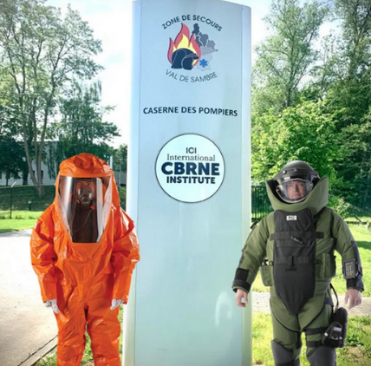
The year 2025 was extremely productive, in terms of the visibility of our institution, now hosted by the Val de Sambre Rescue Zone (made up of an operational staff of around 240 professional firefighters, volunteer firefighters, and ambulance drivers, as well as an administrative staff of 22 people, and managed by Colonel Marc Gilbert)
In fact, no less than 30 countries were represented by delegates during this year, either through their participation in our conferences or for having attended our courses. The focus this year has been set on the new courses given to emergency department staff of our hospitals on the one hand and on increasing our international visibility in the field of crisis management and robotics on the other hand.
The International CBRNE Institute has been extended to a Medical Knowledge Centre (MED-KC) entrusted to the Dr Frank VAN TRIMPONT, Anesthesiologist and Emergency Physicist, Director of the disaster certificate course at the Free University of Brussels (partially delivered at the ICI with a specific CBRN course), Secretary General of the European Council for Disaster Medicine, Reserve Officer of the Belgian Army.

The ICI also welcomed a new partner from Australia, namely EPE: EPE enables Australians and their allies to safely operate in high-threat environments, providing Force Protection, CBRN Defence (CBRND) and counter-threat solutions to First Responders, Defence Forces, Law Enforcement, and other government agencies throughout the Indo-Pacific region. Welcome to Jim Blackburn
EPE. Trusted to Protect | Counter Conventional and Improvised Threats

- ICI activities

The transfer of ICI to our new location (Sambreville) and the return to normal allowed us to materialize our new partnerships (police academy, RPA, firefighters, universities, hospitals), both nationally and internationally. In particular, we improved our cooperation agreement with the French CF-NRBC (https://centrefrancaisnrbc.fr) and the AFIU association. Contacts are now being developed with the Flemish partners.
In the framework of the inter university disaster medicine course, it was decided to develop a 3 days micro certificate CBRNE which would be granted with ECTS credentials by the Unoversity of Brussels. A first course validated the course in March and a second one was held in June; Due to the success of this project, other courses are now planned for 2026 and the future.

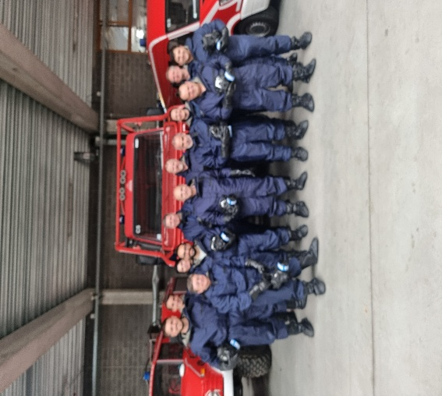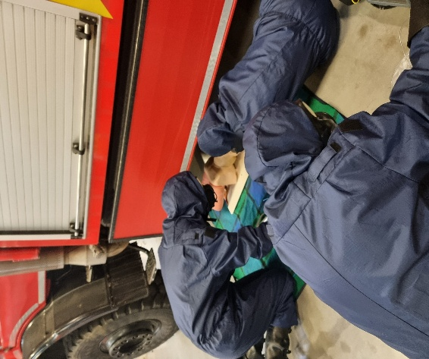

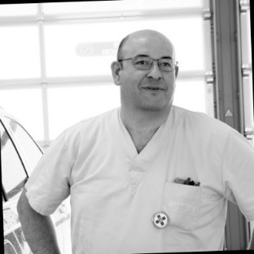 | 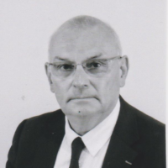
Sébastien Sohet (AFIU) | Claude Lefebvre (CF-NRBC)  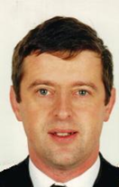  Dr. Jean-Luc Fortin

- Claude Lefebvre is currently a member of the Scientific Council of the Institute of Applied Geopolitics Studies (IEGA), a CBRN expert member of the SAFE CLUSTER, and an expert consultant in the field to the European Defense Commission. Senior instructor of the CBRN KC.

- Sébastien Sohet is coordinator of the ‘'hospital emergency plans' and administrator of the AFIU (Association Francophone des Infirmiers Urgentistes)
Senior instructor of the CBRN Med KC

- Dr. Jean-Luc Fortin Médecine d’urgence is expert in :
- Clinical Medical Toxicology
- Intensive Care for Severe Burns
And, Auditor at the Institute for Advanced Studies in National Defence
- Chief Medical Officer (Ret.) – Armed Forces Health Service – BA 942 Lyon Mont-Verdun
- Instructor – International CBRNE Institute / Sambreville (Belgium)
- Inter-University Diploma in Burn Management / Paris – Paris-Descartes University
- Senior instructor of the CBRN Med KC

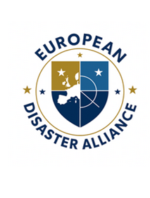
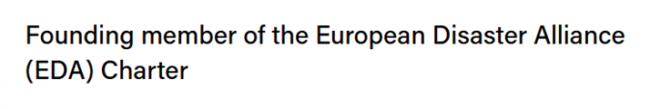

A significant milestone for Europe, and a moment of pride for us all.

On September 26, 2025, at the European Parliament in Brussels, we witnessed something truly special: the launch of the European Alliance Against Disasters.

What began as a shared vision has now become a reality. Five leading organizations, each with unique expertise, came together to sign the Collaboration Charter:

- European Centre for Disaster Medicine - CEMEC
- European Council of Disaster Medicine - ECDM
- World Association for Disaster and Emergency Medicine (WADEM) - European Chapter
- Counter-Terrorism Medicine Europe - CTM-E
- International CBRNE Institute - ICI

The Alliance is committed to building joint training and education programs, strengthening health preparedness for disasters across borders, harmonizing policies and standards, and above all, saving lives through cooperation and solidarity.

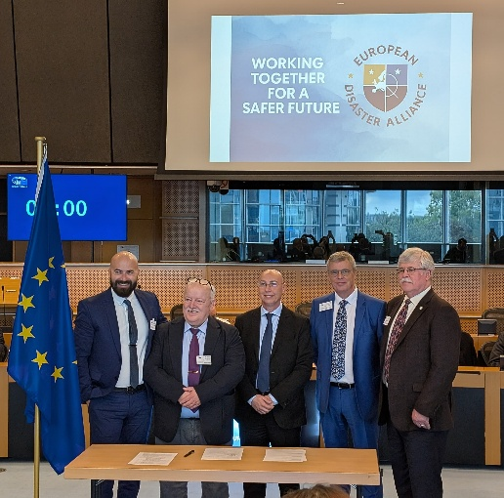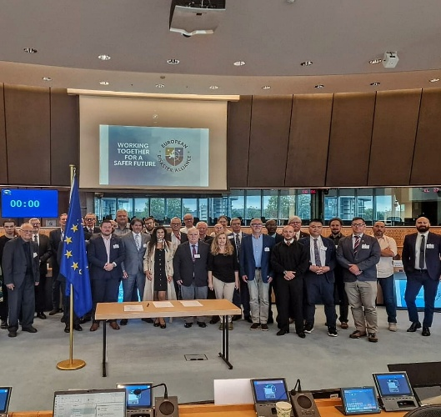

- ICI/ER-KC (Explosives/Robotics)

26th ISMCR 2025 : International IMEKO Symposium on Measurement and Control of Robotics

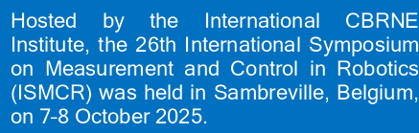
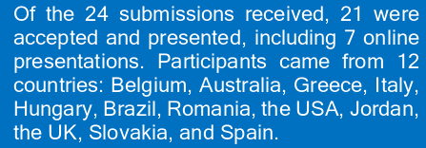

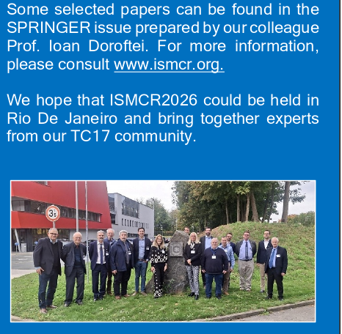

PASTA – PARADIGM FOR THE SYNERGY OF MINE ACTION AND AGRICULTURAL DEVELOPMENT

Coordinated by the ICI, supported by the Italian IIT/Snail-Aid SME (and, among other tools, its robot Disamardillo), a new proposal has been introduced by the end of November as an answer to the EC call HORIZON-L3-2025-01-FCT-04
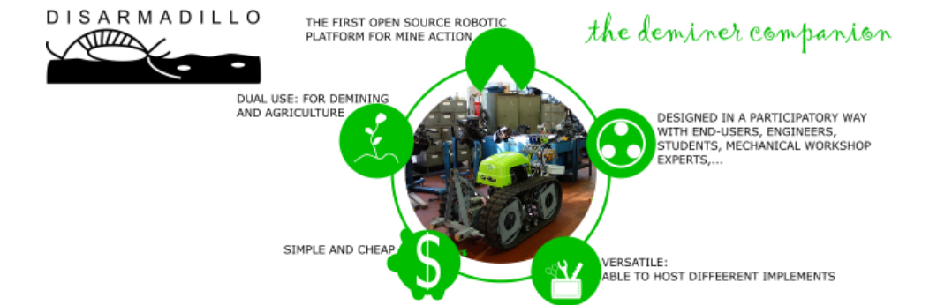
PASTA is an innovative paradigm aimed at radically innovating the approach to humanitarian demining and post-conflict development by integrating them seamlessly. The core premise is that many of the challenges in humanitarian demining have technological parallels in agriculture — both involve processing, preparing, and rehabilitating soil. While humanitarian demining is often treated as a highly specialized and isolated sector, the truth is that a significant overlap exists in machinery, sensing technologies, robotic systems, operational and management techniques. Even Explosive Ordnance Risk Education (EORE) frequently relies on the same tools used in agricultural knowledge exchange, such as radio broadcasts. PASTA seeks to revolutionize mine action by adopting a cost-efficiency–driven agricultural approach, while simultaneously channelling the tools employed for demining to strengthen agricultural development. This two-way integration ensures that humanitarian demining benefits from agricultural knowledge, innovations, and a cost-efficiency-driven approach, while agriculture itself gains from mine action technologies introduced in the country.

- ICI/CBRN-KC
- A series of courses/training has been organized every month according to the following objectives and their level, with a participation of 10 to 15 candidates/session. Claude Lefebvre and Sebastien Sohet assisted the chairman of the ICI. The last training was organized in November at the new site of ICI. Objective: To enable emergency services personnel to continue their mission in a contaminated environment in the event of a terrorist attack or a major CBRN or industrial accident (nuclear, Seveso plant, etc).

Level 1: e-learning, basic information on CBRN issues
Level 2: Information on the basics of the threat, protection, decontamination, and
procedures for dressing and undressing in a CBRNE situation
Level 3: Advanced: recognize, detect, protect, and decontaminate CBRN victims +
medical countermeasures and first aid in a CBRN environment. Practical
scenarios

- As usual, ICI edited its monthly publication, under the responsibility of the CBRN-KC manager/editor, exploded!

Brigadier General (ret.) Ioannis [John] Galatas, MD, MSc(Terr), MC(Army)
MD Consultant in Allergy & Clinical Immunology
Medical/Hospital/Ops CBRNE Planner/Instructor
Senior Asymmetric Threats Analyst
Editor-in-Chief: "HZS C2BRNE DIARY"
Research Associate @ Center for Security Studies (KEMEA) (Greece)
Manager @ CBRN Knowledge Center, International CBRNE Institute (Belgium)
Senior Advisor @ Research Institute for European and American Studies (RIEAS - Greece)
Mob: +30 6944 502757 (Viber & WhatsApp)



- European Project UPCM OVERCOME: this project ended in April 2025 with the development of PROMETHEUS, a management software for cross-border crisis, tested by our French and Italian partners, on the basis of CBRN threats proposed by an ICI survey.

- INTEGRA INTEGRATED ALERT AND DETECTION SYSTEM FOR CROSS-
BORDER CBRN EMERGENCIES IN THE EU

Coordinated by IBATECH Technología SLU (Spain) with the support of 12 partners (including ICI), in answer to the Call Horizon CL3-2025-01-DRS 03
The INTEGRA-CBRN project proposes the development of a modular, interoperable cross-border alert system capable of integrating existing national and regional infrastructures. By standardising information sharing/communication protocols and enabling the fusion of multi-source detection data:
the European Union (EU) is increasingly exposed to a wide spectrum of CBRN (chemical, biological, radiological, and nuclear) risks, driven by factors such as rising geopolitical tensions, climate change-induced vulnerabilities, and the intensification of global travel and trade. These threats are inherently transboundary and require cohesive, multinational coordination to be effectively addressed. However, the EU currently does not exploit a unified approach to early detection and alerting, with existing systems operating in isolation, often based on differing technical standards and lacking interoperability.

- CivPro-Linc: Civil Protection Liaison-Network Course (March 2025, August 2026)

In answer to the UCPM call Knowledge for Action in Prevention and Preparedness (UCPM-2024-KAPP), coordinated by Bezirksregierung Köln with the support of NL and BE partners.
The goal of the project CivPro-LiNC (Civil Protection Liaison-Network Course) is to strengthen the cooperation and coordination among UCPM Member States in border regions in order to improve preparedness for responding to natural and man-made disasters under the threshold of UCPM activation. It complements and supports the Host Nation Support System (HNS) of the Member States and within the UCPM by training specialised civil protection personnel, building a network and preparing them for incoming assistance and cross-border coordination in the event of small and medium-sized local and regional disasters
ICI is in charge of the organisation of a TTX based on a CBRN accident.

- ICI/MED-KC

Frank Van trimpont is an Anaesthesiologist and emergency physician, interested not only in emergency medicine but also very much for disaster medicine. Interested in a pedagogic way by being the Academic supervisor of the Certificate of the management of Disaster Situations that he created over 10 years ago, or in a practical way through various humanitarian missions in the Philippines, in Palestine, in the Congo, in Sumatra, among other areas.
He had the chance to be the Assistant General Secretary of the French Society of Disaster Medicine before being one of the founding members of the European Council of Disaster Medicine and the current President.
Disaster medicine is an exciting discipline and is insufficiently explored as a field of research.
The Interuniversity Certificate in Multidisciplinary Management of Exceptional Situations was held this year (November) at the premises of ICI Belgium, a partner of this certificate. It consisted of two times three days of courses that addressed the legal bases of the organization of relief, the presentation of the different disciplines, the first minutes of disaster management, as well as the organization of relief from the construction site to hospital admission through the management of the advanced medical post. The different types of risks are then considered, rail accidents, airplane accidents, food poisoning, organization of preventive devices, nuclear, chemical, bacteriological risk, etc.
This training brought together candidates from all disciplines.
This programme is co-managed by the Universities ULB (Brussels), ULG
(Liège), UCL(Louvain-la-Neuve), and RMA.
As mentioned here above, two courses were organized with success in the framework of the ULB micro certification CBRN and other are already planned in 2026.

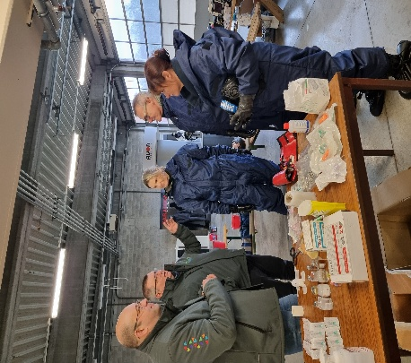

2. Planning 2026 due to the unexpected threats (Ukrainian status, among others) dates of events and new ones may be adapted – read www.ici-belgium.be / events

CBRNE Training (January to December 2026)

NEW !
A new course TE3C (TECC in Contaminated environment) will be organized in collaboration with the firm SMAT Trg from next year on. 3 courses are already planned in March (full!), April & Octobre…be proactive, the places are limited!!

17-18 September 2026, organization of the 27th IMEKO-ISMCR in Rio De Janeiro (www.ismcr.org)

August 2027: I XXVII IMEKO World Congress in RIMINI with participation of the TC17.
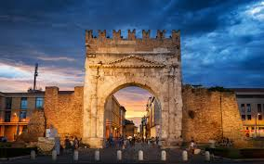
The organisation of the IMEKO World Congress 2027 is actively underway, with several essential steps already completed and many others in progress. The event will take place in Rimini, Italy, from the 30th of August to the 3rd of September 2027, bringing the global metrology community together in one of Italy's most vibrant and accessible conference destinations.

As part of its many activities (conferences, symposium, workshops, courses, etc.) ICI constantly tries to stay at the forefront of the materials made available to trainees and visitors. This could not be a reality without the support, in 2025, of our sponsors Blücher, Ouvry, EPE…) whom we thank for their permanent support for our activities.

LAST BUT NOT LEAST, best wishes to all of you and your families, Health and Happiness throughout the coming New Year 2026!

